ABSENCE QUOTA PROCESSING

**LLSD**

**Version 6.00**

DOCUMENT ORIGIN

|  |  |
| --- | --- |
| AUTHORS | OPERATION UNIT |
|  |  |
|  |  |
|  |  |

CHANGE HISTORY

|  |  |  |
| --- | --- | --- |
| VERSION | DATE | CHANGES |
| 1.04 | 7/15/2009 | Added PNWD AIP, Illness Restoration for Rehires, Removed PNWD Cap and Monthly Comp Time Cap, Updated PN & KC Adjustment Wording, Updated Catastrophic Illness Process |
| 1.05 | 7/20/2009 | Added Rehire Process for PN/KC. Added Deceased Employee exempt from illness recovery, added report requirements, defined retroactive WSR change procedure |
| 1.06 | 8/10/2009 | Updated from Teri’s Feedback. Illness Matrix additions, issues regarding vacation LSV, classified management probationary details, limited contract teacher details, benefits ending reporting details |
| 1.07 | 8/17/2009 | Change to PN policy for 1EXX, Update Catastrophic Illness rules, change Comp Time cap process (no auto OT), remove illness adjustment process for end of assignment, PNWD AIP rule clarity |
| 1.08 | 8/19/2009 | Exclude Z-basis assignment from PN/KC adjustment process/day calculation and illness projections |
| 1.09 | 9/9/2009 | Updated 2U* Vacation accrual factor  Added STRS/PERS bullet for Catastrophic Illness |
| 1.10 | 9/10/2009 | Updates to Illness Process for FTE, Flip-Flop logic, and Unearned Illness Frequency |
| 1.11 | 9/11/2009 | Add Home School Teachers projection rules to Half-Pay descriptions. Update effective date of changes (where known). Update Catastrophic Illness logic to exclude earned illness calculation. Update Maximum illness per year. |
| 1.12 | 9/29/2009 | Illness Flip Flop clarification, Updated Vacation Cap Adjustment Period |
| 1.13 | 10/14/2009 | Refinement of Flip Flop requirements |
| 1.14 | 10/21/2009 | Refinement of Flip Flop requirements. Update to Vacation Cap Calculation, Update Illness Separation and Rehire Process, Update KC & PN Rehire, Remove Vacation->Illness rule from Catastrophic Illness, Remove True Illness Calculation for additional assignment illness adjustment |
| 1.15 | 11/5/2009 | Illness restoration on rehire limited to specific actions, AIP INHR details, Change to language for projections for employees on leave |
| 1.16 | 11/17/2009 | Added special Z1, Z2 case for PA 2MCX, no PN/KC without projection, CI Roll-Over adds to balance, Return from CI illness is kept, PNWD on assignment only, AIP changes are effective 7/1/2009, Remove Rounding |
| 1.17 | 12/9/2009 | PN/KC will not adjust when an assignment changes. Cat Illness projection upon return from leave is reduced by remaining balance. Vacation Lump Sum effective date |
| 1.18 | 1/7/2010 | PN/KC project when a person becomes eligible for PN/KC for the first time. Remove wording from Vac Cap "employee shall cease to accrue" |
| 1.19 | 1/20/2010 | CTXX Projection should be 66 hours effective 7/1/2009. CTXX special illness rules are for 2UTK only. |
| 1.20 | 2/2/2010 | Update 10/90 + CI process, no roll-over if no projection |
| 1.21 | 2/19/2010 | PN/KC should adjust with a flip-flop |
| 1.22 | 2/24/2010 | Stop Illness Adjustment for new Assignment when illness max is reached  Reword PN/KC Flip-flop |
| 1.23 | 4/2/2010 | Effective Date changes |
| 1.24 | 4/14/2010 | Configuration Notes |
| 2.01 | 7/22/2010 | Update to Vacation Excess Description |
| 2.02 | 12/16/2010 | **R1779** - Adding Probationary Illness Section (Only a comment, no signature required)  **R1604** – Fixing holiday generation on the last active day of an employee with lump sum vacation payout (No change to the business rules, only a break-fix) |
| 2.02 | 04/26/2012 | **R2285** – Half Illness Corrections by using IT2013  **Background:**  The total yearly IL hours (sum of FP and HP hours) are capped based on the assignment hours of the EE on the projection day, unless the EE is eligible for a flip-flop or getting an additional assignment. Midyear assignment hours don’t change this cap.  In this case, assignment hours are 4 on 7/1/09. So the total Yearly IL days are 100 * 4 = 400 hours. That means the yearly cap is 400 hours. If the sum of FP and HP hours after the correction exceeds 400, hours that exceed 400 is removed from the HP quota. There is no work around for this.  A change to the config has been made to accommodate a manual correction. Subtype ZIHR has been created in IT2012 so that a change to Half-Pay Illness in IT2013 can be made possible.  A request was made to Security to give RH004_0000 Time Data Maintainer [Payroll Services Branch] the access to the new Time Type ZIHR in IT2012 with update capability.  See appendix C for the new time type subtype. |
| 2.02 | 04/19/2012 | **R2286** – 10 & 90 Illness Projection  – This request is to trigger the time schema to generate illness projection whenever a 10&90 action code is processed in the system. The dynamic action was modified to create an IT2012 record upon execution of the action code NN with a July 1st date. The flag Z109 is then used to feed the time evaluation to trigger the 10/90 projection (just on the begin day).  Refer to Appendix C for info on time type. |
| 3.01 | 08/01/2012 | **R2679** – PNWD Accrual Rate change for Non-Degree Track employees (2FNX)  ***NOTE:*** *The new accrual factor of 0.0167 which is effective July 1, 2007 was modified in SAP via R2679.*  *However, the request to implement this change was only made aware to ITD-BASE by Payroll Services Branch on the 3rd quarter of Fiscal Year 2011-2012. With Payroll Services’ decision to avoid more system problems, the new accrual rate will be applied effective July 1, 2012 going forward. Retroactive accruals (for periods 07/01/2007 thru 06/30/2012) will be addressed on a case by case basis.* |
| 4.01 | 04/15/2013 | **R2748** – Refinement of July 4th HO donation for Sworn Officers assigned 10 hours per day and their regular OFF day fall on Fourth of July. Four hours will be donated and the remaining 6 will be converted to comp at one and a half.  **Please refer to the Holiday Business Rules Doc under Rule 17. on the new requirement.** |
| 5.00 | 04/01/2014 | While addressing a production issue on illness projection, it was discerned that there is a need to include an appendix of SAP action codes that the Time schema reads to project illness hours. Aside from the beginning of the Fiscal year (July 1st), illness projections are also granted for those action codes that are processed any day within the Fiscal Year to illness-eligible employees. |
| 5.00 | 04/21/2014 | Adding the new PAs (1LJX and 1VJX) to the Vacation Accrual Rates table. |
| 6.00 | 9/1/2014 | **R6153** – Correct the vacation accrual rate from 0.08462 to 0.07693 going forward 7/1/14 for certificated management (PA=2MEX, 2MSX, 2MZX) with District Years of Service 19~23. Modified Appendix A “Vacation Accrual factor”. |
| 6.00 | 11/5/2014 | **Adding the explanation behind constant ZQFCF under Appendix F** |
| 7.00 | 9/22/15 | **R6889 - Comp time for Unit A&H non-Sworn officers** |
| 8.00 | 04/20/2016 | R7222 – Local99 Conversion to SM –  Regression testing of Time processes with regards to payroll area changes- Added notes for IT2012 subtype VOUT under Vacation. |
| 9.00 | 5/1/17 | ZSEP processing changes Appendix G |
| 10.0 | 7/7/2017 | **Paid Parental Leave Process**  **For more information, please see the Paid Parental requirements document under Time.** |
|  | 03/14/2022 | **AB2393 Parental Leave – W**hen an employee is terminated, resigned, or retired with an unearned illness balance, do NOT collect the unearned illness balance caused by PL time. PL will be excluded from usage for the unearned illness calculation. |
|  | 5/13/22 | R9958 - Vacation stopping accrual from 7/1/2022 every end of pay period at the CAP. |
|  | 5/19/23 | **R10475 SBTM for Limited Contract Teachers –** Update to add info related to Job 11100781. Not entitled to illness but entitled to SBTM. 11100781 and ESG/T1 was corrected to receive SBTM effective 7/1/22 |

REVIEW AND APPROVAL

|  |  |  |  |  |
| --- | --- | --- | --- | --- |
| Versions | DEPARTMENT | NAME | DATE | SIGNATURE |
| V 3.01 | LLSD |  | 8/1/12 |  |
| V 3.01 | LLSD |  | 8/1/12 |  |
|  | LLSD |  |  |  |
|  | LLSD |  |  |  |

DISTRIBUTION

|  |  |
| --- | --- |
| COMPANY | NAME |
| LLSD |  |
| LLSD |  |
| LLSD |  |

# Contents

Contents 7

Introduction 8

Vacation 8

Illness 12

NOTE: Illness Projection during Parental Leave (AB2393) 15

Personal Necessity 23

Kin Care 24

Paid Non-Working Days (PNWD) 26

Compensatory Time 27

Miscellaneous Rules 30

Parental Leave Quota and Process 31

For more information, please see the Paid Parental requirements document under Time. 31

Military Disability Quota and Process 31

For more information, please see the document “Military Disability Leave Requirements Document.doc” in the Time-> Absence Quotas folder of Sharepoint. 31

Reporting Requirements 32

QUOTA mapping to Time/Wage Type and Remuneration Statement (paystub): 32

Appendix A: Vacation Accrual Rates (These Factors are housed at Payroll Parameter Table T511K-ZQFC*) 34

Appendix B: Illness Projection Values by Personnel Subarea 36

Appendix C: SAP Configuration Notes 38

Appendix D: Addendum to Bargaining Contract Agreements 42

Appendix E: HR Action Codes and Action Type: 42

Appendix F: Vacation Accrual Factors 43

Appendix G: ZSEP and payout: 45

Appendix F: Vacation Accrual Factors: 38

Appendix G: ZSEP and Quota Payout: 40

# Introduction

The purpose of this document is to describe in detail the rules for processing absence quotas at LLSD. Included processes within absence quota processing include quota generation, entitlement, projections, usage, eligibility and payouts associated with Illness, Vacation, Personnel Necessity, Kin Care, PNWD, and Compensation Time Quotas. Included in these business rule descriptions is special cases and special processing for managing employees with concurrent assignments. The business rules established in this document will be used as a basis for configuration management of SAP.

# Vacation

Vacation is a period of suspension of work taken at a time convenient to the employee provided that it is scheduled in advance and, as determined by his/her supervisor, would not interfere with the operation of the unit.

Vested vacation is the amount of vacation from the 1994 accrual bank which may be utilized by an employee. The District tracks this balance as a grandfathered amount which is above the 1994 established vacation accrual maximum.

## Eligibility

The following types of employees are eligible to accrue vacation:

1. Regular Classified Employees
2. Certificated, A-Basis employees.
3. Television Studio Assistants
4. Certificated, A-Basis Employees on *Detached Service* Leave.

|  |  |  |  |
| --- | --- | --- | --- |
| **PA** | **PSA** | **EG** | **ESG** |
| All PA's that start with '1' & '2' | For PAs that start with '1':  All PSA's except the ones that start with 'X' and 'R' **EXCEPTION: (If PA=1DTX and PSA=XXXX)** For PAs that start with '2':  PSA=A*** except **AXSX for 2UTE** | A, C, D, E, G, H | All ESG's except A2, N1, N2, N3, S1, X2, Z1 & Z2  **EXCEPTION: (If ESG=Z1/Z2 and PA=2MCX PSA=AGXX)** |

## Vacation Accruals and Entitlements

Employees earn vacation credit for each hour in which pay is received, excluding overtime. The vacation accrual factor is based on a combination of the employee's district years of service, their personnel area, and in some cases, their assignment hours. Refer to **Appendix A: Vacation Accrual Rates** for the matrix describing the vacation accrual rate by years of service and personnel area. (Note: The employee’s district years of service (time type DYRS) is incremented each year, if the employee has completed 130 days by June 30 (Time Type PDAY)).

Additionally, vacation entitlements are granted for the following reasons:

* Classified /AALA illness incentive eligibility (AIP) [See process description for more details]
* Non-sworn officers (PA = 1APW, 1APX, 1ASX and 1SAS) who are assigned a 440 work schedule are credited with 15 hours of vacation time if a Legal Holiday falls during their OFF day.
* Bidding attendance of bus drivers and fleet maintenance workers (VBID) [See process description for more details]

## Vacation Accrual Maximum

(prior to 7/1/22 Each year on July 1st,) Post 7/1/22 at the end of every Pay period an employee's total vacation balance may accumulate unused vacation up to an amount not to exceed that which the employee earns in 18 months (the employee's "vacation maximum earnings"). Z-basis assignments are excluded from this calculation. These values can be achieved using the formula below ***based on the June 30th values***:

18-MONTH CAP = [**21.75 x assignment hours x VA accrual factor x 18**]

* For employees with multiple assignments, the 18-month cap is calculated for each vacation eligible assignment excluding personnel subareas beginning with Z (Z-basis).
* The total 18-month cap for the person is the sum of each assignment’s cap.
* The maximum 18-month vacation cap for a person is 290 hours.
* If a person's assignment hours or vacation factor ever decrease, the employee retains the highest 18-month cap value attained in their career until the vacation balance becomes zero. Once the vacation balance is zero, a new vacation cap is calculated based on their current assignment(s). [1]
* The true maximum vacation a person allowed is this value plus any vested vacation hours the employee earned.

MAXIMUM VAC ALLOWED = [**PERSON 18-MONTH CAP + VESTED VAC BALANCE]**

(prior to 7/1/22 -At the end of the fiscal year) Post 7/1/22 at every end of pay period, if the employee has accrued vacation in an amount in excess to the employee’s vacation cap amount, the employee's excess vacation will be removed from the quota balance. However, the District is choosing to only to enforce this rule in SAP effective 7/1/2010. Prior to that date, the excess vacation amount should be tracked and reported to each employee.

## Usage

* A regular employee may use earned vacation up to the number of hours earned. The rate of pay during vacation shall be the employee's current rate.
* A minimum of 1 hour vacation must be used.
* Some employees may be required to take vacation during the school year on days designated as school holidays (winter recess, spring recess).
* The amount of vacation taken in any pay period cannot exceed the amount of vacation credit earned by the close of the immediately preceding pay period.
* Employees ineligible to accrue vacation can still use vacation accrued from an eligible position. The vacation must be used during the on-track period. These vacation absence hours should be paid at the current assignment’s rate of pay.

## Vacation accrual to stop at CAP

* On 7/1/22 zapping will still happen like prior years. So employees who are in excess of CAP will lose that.
* Post 7/1/22 employee will not exceed the CAP since every end of pay period the accrual is not posted the part that will exceed CAP. So mostly employees will NOT see Vacation balance more than the CAP. There are scenarios of retro-active master data change that can increase your vacation balance over the CAP. In this scenario employees will lose their excess vacation due to balance being higher than CAP.
* Waivers with VWAV can still be entered with a date range. Once the date range expired excess vacation will be lost.
* Multiple waivers can also be managed in PA2012 as below
* Employee gets 24 hrs waiver on 11/25/22 for a year and then another 16 hrs on 4/1/23 both for 1 year.

|  |  |  |  |  |  |  |
| --- | --- | --- | --- | --- | --- | --- |
| **PA2012 - VWAV for multiple waivers** | | | | | | |
| Ex. EE with cap 289 | Waiver Date | Waived hours | PA2012 Start date | PA2012 End date | PA2012 hrs | You can report each waiver as is with start and end dates |
|  | 11/25/2022 | 24 | 11/25/2022 | 11/24/2023 | 24 | System will account for Waived hrs as 24 hrs from 11/25/22 to 3/31/23. Then it will account for waiver as 40 hrs from 4/1/23 to 11/24/23. |
|  | 4/1/2023 | 16 | 4/1/2023 | 3/31/2024 | 16 | System will account for Waived hrs as 16 hrs from 11/25/23 to 3/31/24. |

* Time type VZAP will hold the hrs that was not accrued or zapped. (ZAP happened once waiver expired for example otherwise it simply does not accrue in normal cases)
* Currently employees get AIP at end of Fiscal year. As of now that will get zapped in the next pay period after the 7/1/YYYY.
* VWAV in SALDO will always show the current waiver.

## Fiori Vacation Balance report

See document “Fiori Time team Requirements Document.docx” for Fiori vaacation balance report.

## Vested Vacation Adjustment

At every end of pay period employees’ vested vacation balance is adjusted. If the vested vacation balance is greater than the total vacation balance remaining at the end of the pay period, the vested vacation balance is reduced to equal the total vacation balance.

## Payout

Upon separation from employment, a permanent employee[2] is entitled to a lump sum compensation for all unused vacation time. In computing pay for vacation, all applicable salary differentials shall be included and vacations shall be paid at the base salary rate in effect at the time the vacation is paid.

See Appendix G for payout and Quota reset examples and Process explanation.

Employees who have moved out of a vacation eligible assignment are entitled to a lump sum compensation of their vacation balance either upon request or on June 30th after they have been out of the assignment for more than a year. The vacation balance should be paid at the salary rate the employee held when they were vacation eligible. [3]

*NOTE: The creation of VOUT on IT2012 should be made effective any day of the month where no IT14 is generated. Otherwise, VOUT will only wipe out the balances and will not generate the LSV payout wage types.*

The vested vacation hours of the lump-sum balance will be computed at the employee’s vested rate as of June 30, 1994. This balance is paid first. Any balance in excess of the vested vacation hours up to the maximum vacation earnings will be calculated at the rate in effect on the last day of paid time in the vacation-earning assignment.

No payment for vacation accumulation shall be made to classified employees who terminate employment prior to completion of 130 days of paid service.

## Attendance Incentive Plan (AIP)[4]

The attendance incentive plan grants additional vacation days for certain bargaining group employees who achieve a true full pay illness balance goal. Initially, all employees have a goal of 50 days of illness (others have a goal converted from legacy into time type INGO). On June 30th, if the true full-pay illness balance is greater than or equal to the AIP goal of 50 days, 2 additional vacation days are granted. Going forward, the illness goal is incremented by 25 days. Each year on June 30th, if the illness goal is achieved, 1 additional day of vacation is granted and the goal is incremented again by 25 days. [Note: 1 day of vacation is capped at 8 hours]. The illness balance on June 30th should be reduced by the employee's true illness balance for fiscal year 1994-1995. In SAP, these hours were loaded into time type INHR.

The following enterprise groupings are eligible for AIP:

|  |  |  |  |
| --- | --- | --- | --- |
| **PA** | **PSA** | **EG** | **ESG** |
| 1BXX, 1CXX, 1EXX, 1SLX, 1LAX, 1SAX, 1SXX, 1SLL, 1LVX, 1LJX, 1LMX, 1VAC, 1VAD, 1VSX, 1VVX, 1VEX, 1VJX, 1YLX, 1ZDX, 1ZSX,1ZXX ,1ZLX, 1NXX, 1SAS | All except PSA’s that start with **“X’ and “Z”** | A, C, D, E, G, H | All ESG's except A2, N1, N2, N3, S1, X2, Z1 & Z2 |
| 2MCX, 2MEX, 2MSX, 2MZX | All PSAs that start with **“A”** | A, C, D, E, G, H | All ESG's except A2, N1, N2, N3, S1, X2, Z1 & Z2 |

## Transportation Vacation Bidding (VBID)

The Bus Drivers attend a bid they are entitled to receive vacation accrual as compensation. The District is required to give employees (in the below groupings) 2 hours vacation credit when they attend bids in June and August for a total of 4 hours of vacation credit.

|  |  |  |
| --- | --- | --- |
| **PA** | **PSA** | **Job Key** |
| 1CXX | All PSA's except the ones that start with 'X' and 'R' | 22305804 = Area Bus Supervisor  22305806 = Assistant Area Bus Supervisor  22305826 = Heavy Bus Driver  22305861 = Light Bus Driver  22305864 = Light Bus Driver |

The Fleet Maintenance (groupings below) receives vacation accrual for bidding once a year (2 hours).

|  |  |  |
| --- | --- | --- |
| **PA** | **PSA** | **Cost Center** |
| 1CXX | All PSA's except the ones that start with 'X' and 'R' | 9128401 |

## Detached Service Vacation Process

Employees on detached service are on leave from LLSD and are working for another organization. While on the detached service leave, they continue to stay active on the LLSD payroll and continue to accrue vacation. However, any vacation accrued while on the detached service must be used before returning to active status with LLSD. Any vacation earned and not used while on a detached service leave is lost upon return to the District. Any vacation earned prior to going on detached service, can be used while on the leave.

Upon return from a detached service leave, an employee cannot have a higher vacation balance than when they were put on leave. Vacation earned on detached service should not be factored as part of the total vacation maximum. Vacation earned on detached service should not be paid out in any lump sum vacation payments. Employees on detached service should return to regular service with the District before separating.

# Illness

Illness is absence due to a health related condition. Illness benefits occur in two types: Full-Pay and Half-Pay. The business rules below describe how illness benefits are granted, used, and paid for an employee

## Eligibility

The following employee groups are eligible to receive illness benefits:

* Certificated employees excluding Teacher Assistants (All PA's that start with '2' except 2FDX & 2FNX)
* Classified Employees (All PA's that start with '1' )

|  |  |  |  |
| --- | --- | --- | --- |
| **PA** | **PSA** | **EEG** | **ESG** |
| All PA's that start with '1' & '2' except 2FDX & 2FNX | All PSA's except the ones that start with 'X' and 'R' **EXCEPTION:** (If PA=1DTX and PSA=XXXX) | A, C, D, E, G, H | All ESG's except A2, N1, N2, N3, S1, X2, Z1 & Z2  **EXCEPTION: (If ESG=Z1/Z2 and PA=2MCX PSA=AGXX)** |

* Limited Contract Teacher (Job key 11100781) assigned to all 2UTK and T1, Z1 & Z2 combinations should not receive any illness quotas but are entitled to SBTM.
* Employees assignment to PA 2MCX, PSA AGXX with ESG Z1, Z2 are entitled to quotas despite being return retirees. However, they should only receive 18 days maximum (F factor) of vacation and are not entitled to a lump sum payout upon separation.

## Earned Full-Pay Illness Accrual

Employees eligible for illness can use their illness balance immediately; however, employees accrue full-pay illness based on hours paid. Accrued full-pay illness hours are referred to as “earned illness” and the usable illness entitlement is referred to as “projected illness”. [See “Usage” for probationary period exception]. Full-pay illness is earned as follows:

* 0.05 hours of full pay illness absence credit is earned for each paid hour except overtime.
* EXCEPTION: Assignments in Personnel Subarea CTXX earn 0.054 hours of full pay illness absence credit for certificated UTLA employees assigned to Concept 6 schools ("T" basis).

Paid hours include only regular time, make-up, z-time, miscellaneous time, professional development, and paid absence hours.

## Illness Projection

### Eligibility

All assignments should receive a projections excluding Z-basis.

### Frequency of Projection

Projections are granted upon the following events:

* Beginning of the Fiscal year (July 1st) for active employees
* Upon hire or re-hire as an illness eligible employee [Note: Newly hired employees may request to transfer full-pay illness balances earned from other school districts]
* Through a reassignment action to an illness eligible position
* Return from Leave process [See process description for more details]
* 10-90 Approval [See process description for more details]
* Employees on worker’s compensation leave are entitled to illness projection if there are illness hours restored from a previous school year. [See process description for more details]

**NOTE:**

When it’s not July 1st,the system will project illness quota only for certain Action types. Refer to Appendix E for the list of SAP Action codes and their description that automatically project illness.

### Full-Pay Projection Amount

* The Full-Pay Illness Entitlement is projected on July 1st based on the number of days in the basis contract multiplied by the number of assignment hours multiplied by the earnings factor. The matrix in **Appendix B: Illness Projection Values by Personnel Subarea** contains the number of days per personnel subarea (basis) and the total number of projected illness hours for a 6 hour and 8 hour assignment. For assignments with different assignment hours and FTE percentage[5], prorate accordingly. The maximum projection a person will receive is 104 hours. [Note: PSA CTXX projects based on a 0.054 accrual factor]

**Full-Pay Illness Projection = ((assignment hours * contract days * earnings factor) * FTE%**

* For mid-year projections, the entitlement is projected based on the number of days remaining in the fiscal year for the basis contract hours (i.e. assignments hired mid-year).

**Full-Pay Illness Projection = ((assignment hours * (contract days*x) * earnings factor) * FTE%**

**where x=the proportion of remaining months in the contract year**

* Home School Teachers (Personnel Area 2UTH) receive an illness projection based on one-half of their assignment hours (earned illness hours credit proportionate to the actual hours paid for the school year.) [6]

**Full-Pay Illness Projection = ((assignment hours/2) * contract days * earnings factor) * FTE%**

### Half-Pay Projection Amount

* Half-Pay Illness is projected based on 100 days less the full-pay projection. That is, the total illness balance for both full-pay and half-pay should total 100 days.
* 100 days is based on the assignment hours multiplied by 100, then multiplied by the FTE%[7]
* For employees with multiple assignments. The maximum number of illness hours should be 800 hours. If the total number of assignment hours across assignments exceeds 8 hours per days, limit the total illness project (half plus full) to 800 hours.
* For mid-year projections, half-pay illness projection is not pro-rated. The full 100 days (minus the full-pay projection days) is granted.

**Half-Pay Illness Projection = (100 * FTE% * assignment hours) – Full-Pay Illness Projection**

* Home School Teachers (Personnel Area 2UTH) receive an illness projection based on one-half of their assignment hours.[8]

**Half-Pay Illness Projection = (100 * FTE% * (assignment hours/2)) – Full-Pay Illness Projection**

* If full-pay is more than 100 days, no half-pay is projected.

### Projections for employees on a leave[9]

The following criteria should be applied to employees who are on leave:

An employee who is on a paid leave (LA) “act of violence" leave (AA), Family Care Leave – self (AD), Illness (AG), workers’ compensation leave (AJ & AK), Mandatory Illness (AN) or Pregnancy leave (AW), must have one of the following to receive an illness projection:

**Certificated**

* + Has at least one hour of TRUE full-pay illness balance as of June 30th to carryover, or
  + Has been returned to service in the new fiscal year and did not receive a projection on July 1st. (The illness projection may not be used for time prior to the effective date of the return from leave ), or
  + Has been approved for a once-in-a-career extended illness benefit (10 & 90) request. (This should be back dated to July 1st)[10]

**Classified**

* + Has at least one hour of TRUE Full pay illness or at least 1 hour of half pay illness  balance as of June 30th or I hour of vacation balance, or
  + Has been returned to service in the new fiscal year and did not receive a projection on July 1st. (The illness projection may not be used for time prior to the effective date of the return from leave

# NOTE: Illness Projection during Parental Leave (AB2393)

Existing Illness projection rules are applicable to the “Parental Leave of Absence” action (LA/PL).

*For more information regarding Assembly Bill 2393, please refer the Parental Leave Requirements document in SharePoint under Time.*

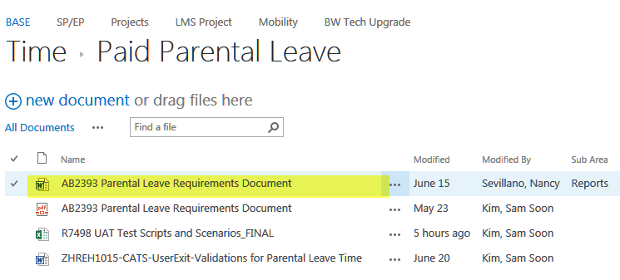

## Changes to Illness Quotas

### Monthly Illness Projection Adjustment (Roll-Over)[11]

On the last day of the month, if an employee’s earned illness is greater than the annual illness projection, the difference should be added to the full-pay balance. The half-pay illness balance should be adjusted appropriately. If employee has exhausted their half-pay illness, there should be no adjustment. No roll-over is processed if the employee does not have an illness projection in the current fiscal year.

### Maximum Job Hours Change (Flip-Flop)[12]

Illness entitlement should be adjusted when certain illness eligible certificated employee’s job hours change. Certificated assignments in personnel areas 2UTH, 2UTE, 2UTA, 2FDX, and 2FNX are not eligible for flip-flopping. Employees in PA 2MCX, PSA AGXX, and ESG Z1 or Z2 are also not eligible for flip-flopping. To determine when to process a flip flop, check the following conditions:

1. When an assignment’s max job hours (IT1010) change, **and**
2. The assignment’s personnel area before the job hours change and personnel area after the job hours change are both illness eligible and flip-flop eligible (certificated, etc.) **and**
3. The assignment hours for the person after the jobs hours change are different than the assignment hours for the person that were used as basis for calculating the employee’s current illness projection (assignment hours are determined by multiplying each illness eligible assignment’s daily working hours by its FTE and then summing them up), **then**
4. If the person’s assignment hours that were used as the basis for calculating the current illness projection equals the old job hours of the changed assignment **and** the person’s assignment hours after the job hours change equal the new job hours of the changed assignment, process the illness flip-flop, **otherwise**
5. If the person has just one assignment, **and** if the person’s assignment hours that were used as the basis for calculating the IL Projection equal or are 50% of the old job hours of the changed assignment, **and** if the person’s assignment hours after the job hours change equal or are 50% of the new job hours of the changed assignment, process the flip-flop, **otherwise**
6. Manual intervention is needed to determine the employee’s illness. (Output an information message).

To calculate the new balances for Full Pay, Half Pay, Illness Projection, Personal Necessity, Kin Care Quotas:

1. The new quota balances (for FP, HP, Projection, Earned, PN, & KC) are equal to the person’s assignment hours after the job hours change divided by the assignment hours that were used as the basis for calculating the illness projection multiplied by the old balance for each respective quota.
2. If the flip-flop occurs on the same day as a new projection (July 1st or return from leave), only the full-pay illness balance needs to be adjusted. The new projection and half-pay amounts will be based on the new assignment information.
3. The assignment hours for a person are determined by multiplying each illness eligible assignment’s daily working hours by its FTE and then summing them up. This value cannot exceed 8 hours

### Additional illness eligible assignments[13]

The Illness entitlement should be adjusted when a new illness eligible assignment is created for a person. Apply the following exceptions:

* If the total illness projection (FP + HP) is 800 hours, and the half-pay balance is zero at the time of the additional assignment, do not adjust the projection.
* If the half-pay illness balance is greater than or equal to the new assignment’s projection amount, then increase the full-pay and reduce the half-pay.
* If the half-pay balance is less than the new assignment’s projection amount and greater than zero, only increase the projection by the remaining half-pay balance (and clear the remaining half-pay balance).
* For employees with more than 800 hours of full-pay illness, who do not receive any half-pay projection, only adjust the full-pay illness projection up to 104 hours per fiscal year and do not project any half-pay illness.

### Restoration of hours due to worker’s compensation

Restoration of illness hours due to worker’s compensation is a manually calculated and input illness balance correction. These additionally added illness hours should result in a new projection for the employee on July 1st. Often this process happens retroactively.

## Usage

* Full-pay illness benefits should be used before available half-pay time may be used.
* Full Pay: Allowed to use the available balance only (projected plus previous earned). Paid at the full hourly rate. To be used for the following absences:
  + - Illness (including FMLA and Worker’s Comp related Illness absences)
    - Personal necessity
    - Kin care
    - Donation for Catastrophic Illness
* Half Pay: Once full pay balance is exhausted; the employee is entitled to use their half-pay illness balance. This should be paid at half the employee’s hourly rate. To be used for illness absences only (including FMLA and Worker’s Comp related Illness absences); not PN, KC, and Donation [Note: Refer to Payroll Processing rules for how to calculate half pay payment.]
* For Classified Employees on probationary status, only six days of illness absence are usable for the first 130 days. For classified supervisory management employees (PA 1L*, 1SLL, 1V*, 1ZLX), beyond the first 6 months of probation, they remain on probation for another 6 months. However, during this next period, there are no restrictions on their illness usage.

## Carry Over

Full pay illness hours shall be cumulative from year to year without limitation.

Half pay illness hours are not carried over the following school year. The half-pay balance is only usable from July 1st through June 30th of the next year (fiscal period).

For employees who have, in a previous year, used more full-pay illness than they earned, full-pay Illness balance is adjusted and reduced by the over-usage.

## Separation

Employees should receive no lump sum salary payment for any unused accumulated illness hours. When an employee leaves the District, their true illness balance is calculated. The half-pay, projection, and earned balances are wiped out and all that should remain is the true illness balance in the full-pay quota. (See illness restoration upon rehire for more details.)

Upon completion of an assignment, other than a separation from the District, all illness quotas should be wiped out. Because other assignments are still active, we do not conduct any reconciliation or true illness calculation for the employee.

When an employee transfers to another district, or to the retirement system (STRS/PERS), the illness balance is zeroed out from the District records. This is a process that occurs on request only.

## Unearned Illness Recovery

At the end of each fiscal or when the assignment changes (i.e. separates or retires, etc) the true illness balance needs to be reconciled to determine if the employee used more illness hours than they earned. This is calculated by adding the Full Pay Illness balance and Illness earned hours up for the year (or to the last active date of the employee) and subtracting the year’s illness projection. If the difference is a positive value, the hours are left in the employee’s record; however, if the difference is negative, the hours will be recovered.

* For new projections or projection adjustments the balance will be reduced by the unearned amount.[14]
* For employees who separate or retire, the unearned hours will be reduced from their lump sum vacation payment (if applicable) or a deduction amount will be sent to payroll for collection.
  + If the employee has some Half Pay Illness balance at the time of the last illness projection in the current fiscal year, Payroll will collect the unearned illness at the half-pay rate. (WT0443)
  + If the employee has NO Half Pay Illness balance at the time of the last projection in the current fiscal year, Payroll will collect the unearned illness at the full-pay rate. (WT0445)
  + If the employee is deceased or retired because of disability, no recover is processed

***03/14/22 AB2393*** *- For more information regarding Assembly Bill 2393, please refer the Parental Leave Requirements document in SharePoint under Time.*

**Separation and Payout**

When an employee is terminated, resigned, or retired with an unearned illness balance, DO NOT collect the unearned illness balance caused by PL time. PL will be excluded from usage for the unearned illness calculation.

*Unearned Illness WITHOUT PL:*

*Unearned Illness = Full pay balance + Accrued Earned Illness – Projected Full pay*

*Unearned Illness WITH PL:*

*Unearned Illness = Full pay balance + Accrued Earned Illness – Projected Full pay + PLIL used this fiscal year only against Full Pay quota*

## Illness Restoration upon Rehire[15]

An employee who separates from the district and is re-instated into the same job classification within 39 months is entitled to have all if their benefits restored including any full pay illness balance. (Note: This can be identified within SAP by looking at action type HR, action reasons AB, AD, and HE). Furthermore, the employee does not have to pass the 130 day probationary period again for using illness. However, beyond 39 months, all full pay illness hours should be reset and probationary period is required.

Additionally, when an employee separates and rehires into the District, they should be treated as a new hire. Upon rehire, a new full-pay illness projection should be generated along with a new half-pay balance using the same formula for any newly hired employee.

## Classified Probationary Illness Leave Validations

Please see Time Types Requirements Document for details.

## Catastrophic Illness [16]

This program is intended for employees who are on a long-term illness leave and in danger of exhausting their illness and vacation benefits. The catastrophic illness process allows active employees to donate their full-pay illness balance to these employees so they may continue to get paid during their leave. Only certificated and classified employees who are eligible to receive illness quota are eligible to participate in the catastrophic illness program.

### Illness Recipient

* The receiving employee must be on a leave and must use all full-pay illness hours and all vacation balance before requesting catastrophic illness donations.
* If the receiving employee is on any type of District leave and receiving any compensation related to LLSD employment (for example, workers’ compensation or disability retirement allowance), the employee is not eligible for a leave donation.
  + - Read IT0000 and confirm there is a record with action type LA and action reason AG or AD with a begin date prior to the donation date. Also confirm there is not an IT0000 with an action type RL with a begin date prior to the donation date. (In other words, confirm the employee is on a paid leave with reason Illness or FMLA-Self and has not yet returned from leave). If these conditions are false, stop processing and output an error stating (“Receiver employee not on a valid leave type”)
* After an initial donation of illness time, employees may receive additional donations only during a 12 consecutive month period. The beginning date of this 12 consecutive month period will begin at the first day of use of donated time. Employees will not be eligible for any additional donations after the exhaustion of the 12 consecutive month period.
* On the date of donation, if there is a half-pay illness balance, it should be reduced by the donated amount.
* Donation of illness time is intended to assist the employee with salary only. Employees on a catastrophic illness leave using donated hours do not continue to accrue vacation or earn illness, do not accumulate years of service, and do not receive step advancement or career increment. However, if the donated illness hours reduced the employee’s half-pay balance, these benefits continue to accrue for the number of hours the employee would have received half pay.
* Donated hours used **do** count towards STRS and PERS creditability.
* Bridging rules for holidays still apply during a catastrophic leave; therefore holidays are still paid. However, holiday pay does not earn illness, accrue vacation, etc. (unless the illness hours used to bridge the holiday are earning illness, etc. because they offset half-pay or were generated through a 7/1 projection).
* Donated time will not be included for determining eligibility for an illness projection for the following fiscal year. However, for classified employees, if the donated illness hours reduced the employee’s half-pay balance, if there would have been a half-pay balance remaining at the end of the fiscal year, the employee should still receive an illness projection.
* For a classified employee on a catastrophic illness leave, who still qualifies for a projection on 7/1, the projection is processed normally by adding the projected full-pay hours to the full-pay quota reduced by the unearned hours in the previous year.
* If an employee receives a roll-over full pay illness adjustment, this balance will add to the balance normally.
* Certificated employees on a catastrophic illness leave must request their 10/90 illness projection. The projection only becomes effective on the following July 1st.
* For an employee who requests a 10/90 on July 1st :
  + If the true illness balance is greater than the projected amount (QT03) because there is a full-pay balance remaining from donations, reduce the FP balance by the unearned portion. The resulting full-pay balance will be less than or equal to the full pay balance before the projection.
  + If the true illness balance with the 10/90 is less than the projected amount because of unearned illness (with or without a donation carry-over), but is still greater than zero, increase the FP balance to equal the projected amount. (Forgive unearned illness). The resulting full-pay balance will be greater than or equal to the full pay balance before the projection, but not greater than the projected quota amount (QT03).
  + If the true illness balance with the 10/90 is less than less than zero (with or without a donation carry-over), reduce the FP balance by the unearned portion. A negative full-pay illness balance may result.
* When a projection occurs for an employee on catastrophic illness (10/90 or regular), the half-pay balance is generated using the 100 days rule.
* When a projection occurs for an employee on catastrophic illness (10/90 or regular), full-pay illness hours used (up to a maximum of 100 days) will earn illness, accrue vacation, etc.
* When an employee returns from leave, the donated hours will remain in the employee's quota and can be used as normal full-pay illness quota. Usage of this illness will earn illness; accrue vacation; etc. regardless of the employee's illness standing when the donation was received.
* When an employee returns from leave, if they are eligible for a projection, process the projection normally; however, the half-pay projection should be reduced by the number of illness hours used before the projection (no less than zero) to align with the 100 days of illness rules.

### Illness Donator

* Only full-pay illness hours that have been accrued by the donating employee can be donated. Half-pay illness and vacation cannot be donated.
* Employees cannot donate illness that has not yet been earned.
* Donated time is transferred in units of days. For example, a 6 hours employee donates 1 day to an 8 hours employee. In this case, 6 hours is reduced from the donating employee’s balance, and 8 hours is added to the receiving employee’s balance.
* A donating employee cannot donate more than 20 days of illness.
* Once made, any donation/transfer of illness time made by an employee is irrevocable. Donated time will not be returned to the donating employee under any circumstances.
* The donation will affect the number of days calculated for the Attendance Incentive Award Program. The hours donated should be counted as if they were absence hours used.

## 10-90 (Extended Illness Benefit)[17]

Certificated employees who are on leave at the end of the fiscal year and have run out of their full-pay illness benefits normally do not receive their illness projection until they return from leave. The extended illness benefit allows illness eligible employees who do not qualify for an illness projection on July to receive a normal illness projection. Unearned illness is forgiven for a 10-90 action and a full illness projection is granted unless the true illness balance on June 30th is less than zero. If the true illness balance is less than zero on June 30th, the 10-90 projection is reduced by the hours less than zero.

Employees can only receive the 10-90 extended illness benefit once in their career.

### Additional rules:

1. For employees with a negative full illness balance at the beginning of the fiscal year:

* The negative amount is deducted from the full pay balance.
* Full pay and half pay illness balance should always be equal to 100 days

1. For employees with Catastrophic illness carry over to the new fiscal year:

* If the carryover hours are added, the 100-day mark should still be considered.
* IF the Full Pay Illness balance is less than the projection (QT03). It should be adjusted not to exceed the illness projection.
* If the FPI balance is greater than the projection then no additional hours should be added to the FPI balance.

1. The usage of the 10 and 90 illness should earn illness and vacation hours.
2. All illness usage should count towards Step Advance, District Years of Service, etc.
3. The effective date of the 10 & 90 is always July 1st where no illness projection was given of that fiscal year.
4. A return action from the paid leave should not trigger another illness projection if a 10 & 90 has been approved for the fiscal year in question.
5. Classified employees are not entitled to 10 & 90 benefit.

# Personal Necessity

Personal Necessity is absence used for illness or injury specifically for the following reasons:

* Death of a member of his or her immediate family when additional leave is required beyond standard bereavement leave
* Accident, to a member of his or her immediate family.
* Appearance in any court a litigant, party, or witness under subpoena.
* Other reasons that the governing board may prescribe.

## Eligibility

All probationary and regular Certificated and Classified employees are entitled to Personal Necessity days. Leave to higher; temporary employees are also eligible due to a regular assignment. All other temporary employees (ESG S1) are not eligible.

|  |  |  |  |
| --- | --- | --- | --- |
| **PA** | **PSA** | **EEG** | **ESG** |
| All PA's that start with '1' & '2' | All PSA's except the ones that start with 'X' and 'R' **EXCEPTION:** (If PA=1DTX and PSA=XXXX) | A, C, D, E, G, H | All ESG's except A2, N1, N2, N3, S1, X2, Z1 & Z2  **EXCEPTION: (If ESG=Z1/Z2 and PA=2MCX PSA=AGXX)** |

## Entitlement and Projection

* Employees are entitled to 6 Personal Necessity (PN) days per fiscal year between July 1st and June 30th.
* District-Represented, CSEA-Represented (Unit D) and Teamster Employees (Unit S) receive one additional Personal necessity day per fiscal year between July 1st and June 30th.

|  |  |
| --- | --- |
| **Personnel Area** | **Days** |
| 1AOX, 1APW, 1APX, 1ASX, 1BXX, 1CXX, 1GXX  2UTA, 2UTE, 2UTH, 2UTK, 2USX | 6 |
| 1LAX, 1LMX, 1LVX, 1NAX, 1NXX, 1SAS[18], 1SAX, 1SLL, 1SLX, 1SXX, 1VAC, 1VAD, 1VEX, 1VVX, 1VSX, 1YLX, 1ZDX, 1ZLX, 1ZSX, 1ZXX, 2MCX, 2MEX, 2PXX, 2MSX, 2MZX, 1DTX, 1DXX, 1DPX | 7 |
| 1EXX | 6 prior to 7/1/2008  7 starting 7/1/2008 |

* Personal Necessity is projected on all eligible assignments on July 1st. To determine the projection amount, multiply the daily entitlement (6 or 7 days) by the assignment hours for each assignment. Exclude Z-basis assignments.[19]
* Personnel Necessity is also projected when an employee is hired, becomes eligible for personnel necessity for the first time, or returns from a leave and receives an illness projection.
* Personnel Necessity is adjusted when a change to the maximum job hours occurs (flip-flop). See Illness for more on flip-flops.[20]
* Employees that do not receive an illness projection do not receive a personal necessity entitlement.

## Usage

To be able to use Personal Necessity an employee must have both, sufficient Full Pay Illness and Personal Necessity balances. If either balance is zero then the employee should not be using PN absence.

For Classified Employees on probationary status, only six days of illness absence are usable for all purposes, including personal necessity.

## Carry Over

Personal Necessity is not carried over from year to year. The balance is renewed every July 1st of the fiscal year.

## Separation

Personal Necessity is not paid out. Upon separation, the Personal Necessity balance should be wiped out.

## Rehire

When an employee is rehired into the District, they receive a new Personal Necessity entitlement even if the rehire occurs within the same fiscal year as the separation.

# Kin Care

Kin Care days are absences used for attending to the illness of a parent, spouse or child.

## Eligibility

All probationary and regular Certificated and Classified employees are entitled to Kin Care days. Leave to higher; temporary employees are also eligible due to a regular assignment. All other temporary employees (ESG T1) are not eligible.

|  |  |  |  |
| --- | --- | --- | --- |
| **PA** | **PSA** | **EEG** | **ESG** |
| All PA's that start with '1' & '2' | All PSA's except the ones that start with 'X' and 'R' **EXCEPTION:** (If PA=1DTX and PSA=XXXX) | A, C, D, E, G, H | All ESG's except A2, N1, N2, N3, S1, X2, Z1 & Z2  **EXCEPTION: (If ESG=Z1/Z2 and PA=2MCX PSA=AGXX)** |

## Entitlement and Projection

* Employees are entitled to 6 Kin Care (KC) days per calendar year between January 1st and December 31st
* Kin Care is projected on all eligible assignments on January 1st. To determine the projection amount, multiply the daily entitlement (6 days) by the assignment hours for each assignment. Exclude Z-basis assignments.[21]
* Kin Care is also projected when an employee is hired, becomes eligible for kin care for the first time, or returns from a leave and receives an illness projection.
* Kin Care is adjusted when a change to the maximum job hours occurs (flip-flop). See Illness for more on flip-flops.[22]
* Employees that do not receive an illness projection do not receive a kin care entitlement

## Usage

To be able to use Kin Care an employee must have both, sufficient Full Pay Illness and Kin Care balance. If either balance is zero then the employee should not be paid.

For Classified Employees on probationary status, only six days of illness absence are usable for all purposes, including kin care.

## Carry Over

Kin Care is not carried over from year to year. The balance is renewed every January 1st of the fiscal year.

## Separation

Kin Care is not paid out. Upon separation, the Kin Care balance should be wiped out.

## Rehire

When an employee is rehired into the District, they receive a new Kin Care entitlement even if the rehire occurs within the same calendar year as the separation.

# Paid Non-Working Days (PNWD)

Teacher Assistant employees do not receive vacation and illness benefits like other employees. Instead, they accrue generic days off the District terms “Paid Non-Working Days” or PNWD.

## Eligibility

Only Teacher Assistants receive and use PNWD

|  |  |  |  |
| --- | --- | --- | --- |
| **PA** | **PSA** | **EEG** | **ESG** |
| 2FDX  2FNX | XXXX | C | T1 |

## Entitlement and Projection

Employees earn PNWD credit for each hour for which pay is received, excluding relief time (ZT). The PNWD accrual factors are:

* Degree track employees (2FDX) accrue at 0.0445 hours of credit for each hour paid.
* Non-degree track employees (2FNX) accrue at 0.0112 hours of credit for each hour paid. [23][24]
* Non-degree track employees (2FNX) accrue at 0.0167 hours of credit for each hour paid.[25]

The higher accrual rate for the Degree Track employees (2FDX) becomes effective the first pay period following submission of a certified transcript or valid certificate from the college.

## Usage

The following absence reasons are valid for PNWD:

* Any legal or school holiday
* Illness
* Vacation
* Personal Necessity
* Kin Care
* Jury Duty Service
* Bereavement
* Other absences permitted under Article XIII of the Unit F Agreement, except industrial injury/illness and family care leave other than one’s own serious health condition.

PNWD is paid at the employee’s hourly rate. This would also include any differentials (example: Bi-lingual).

## Carry Over

Paid non-work days are NOT carried over from year to year. The employees begin to accumulate at the start of every fiscal year on July 1st.

## Payout

Any accrued, unused time will be paid off in a lump sum after the close of the school year. This payment will be issued in the June pay period payroll run. Furthermore, if all of an employee’s assignments are transferred to a non-TA job or terminate the employee’s PNWD balance is paid out on the last active day of the TA assignment.

TAs with perfect attendance will earn 1 PNWD day at the end of the fiscal year, to be included in their PNWD payout. To determine if a TA has perfect attendance, they must work 180 days within the fiscal year. The number of hours in a day is equal to the employee’s assigned hours. The PNWD AIP calculation is performed at the assignment level only.

# Compensatory Time

Compensatory time is time off for School Police Officers to be taken in the future time in lieu of overtime pay.

## Eligibility

Only Sworn School Police Officers are eligible to receive compensatory time in lieu of overtime.

|  |  |  |  |
| --- | --- | --- | --- |
| **PA** | **PSA** | **EEG** | **ESG** |
| PA = 1AOX & 1SAX , 1ASX, 1SAS, 1APW and 1APX | All PSA's except the ones that start with 'X' and 'R' | C, G | All ESG's except A2, N1, N2, N3, S1, X2, Z1 & Z2 |

Note - 1ASX, 1SAS, 1APW and 1APX have CA reporting and CU usage from 1/1/15. Prior to that it was not allowed.

## Entitlement and Projection

* An employee who is eligible for comp time may request that overtime hours worked each pay period be credited to a comp time balance account at the rate of one and one-half (1-1/2) hours for each hour reported.
* A maximum balance of 195 comp time hours per year[26]
* Once the 195 balance maximum is reached, accrual should stop within the annual period even if absences are taken to reduce the balance.[27]
* After reaching the 195 limit, any holiday COMP credits or CA recorded in CATS will then be generated as OT. The remaining COMP accruals will then be divided by 1.5 and quotient will be generated with OT wage type.
* The maximum number of overtime hours worked which can be requested (CA) as compensatory time shall be one hundred thirty (130) hours in any year (Oct 1 thru Sept 30). Once this cap has been reached, the employee should no longer be able to request compensatory time.
* Sworn officers & Non-Sworn who are assigned a 4/40 work schedule will be credited with 15 hours of Comp Time if a Legal Holiday falls during their off day. (If the 195 hour maximum has been reached, these hours should be compensated as overtime pay.)
* Any COMP credit for the 4th of July holiday will be accrued with 11 hours (4 hours will be donated with WT0439).

## Usage

An employee will be allowed to use accrued compensatory time in conjunction with scheduled vacation or at other times where such use will not unduly disrupt work schedules. The hours are paid at the normal pay rate.

## Carry Over

Compensatory time is not carried over the following comp year. The end of the year for purpose of compensatory time is September, 30th

## Payout

Any compensatory time accrued but unused (up to 195 hours) is paid to the employee as a lump sum payment every September 30th, at the current hourly rate. Payment will also be processed upon changing from an assignment eligible for compensatory time[28], retirement or separation from the District.

CA reported on a holiday is considered special comp and will pay separately using wage type 0121 on September 30th. Please refer to Holiday Business Rules and PERS School Police Config documents for more detailed information regarding payout of compensatory time reported on holidays.

Miscellaneous Rules

* Limited Contract Teacher (Job key 11100781) assigned to all 2UTK and T1, Z1 & Z2 combinations should not receive any absence quotas but are entitled to SBTM
* In cases where an employee’s quota value is retroactively adjusted after the quota has been exhausted, any payment the employee received should be collected. The payroll department should then work with the employee and the time-keeper to report an alternative absences reason.
* When an employee’s work schedule changes retroactively after full-day absences have already been reported, the system should pay and deduct quota based on the daily working hours in the new work schedule rule. The payroll department should then work with the employee and the time-keeper to correct and validate the timesheet.
* Employees assignment to PA 2MCX, PSA AGXX with ESG Z1, Z2 are entitled to quotas despite being return retirees. However, they should only receive 18 days maximum (F factor) of vacation and are not entitled to a lump sum payout upon separation.

# Parental Leave Quota and Process

# For more information, please see the Paid Parental requirements document under Time.

# Military Disability Quota and Process

# For more information, please see the document “Military Disability Leave Requirements Document.doc” in the Time-> Absence Quotas folder of Sharepoint.

# Reporting Requirements

## Quota Report (ZHRQUOTA)

Users need to be able to view an employee’s quota balances by assignment for a particular date range and quota type. This report should output the following data:

* Begin Balance and End Balance for a period
* Usage in between period
* Accrual Amounts
* Compensated Amount
* Donated Amount
* Payout Information
* Paid Vs Earned (Illness)

## Benefits End Date Report

Classified employees are terminated once all their illness and vacation quotas are exhausted. In order to input the leave action, HR needs to be able to determine approximately when that date will happen. The following steps should be used to determine this event.

1. Look at illness (full and half pay) and vacation balances.
2. Look at work schedule.
3. If employee uses quota continuously for each schedule work day going forward, determine last work day in which quotas balance still exists to pay employee. (Include vacation accrued during this period.)
4. Output the date in which quotas are exhausted (Benefit Ending Date)
5. If person won’t exhaust by the end of the fiscal year, do not output a Benefits Ending Date
6. See request for more details

# QUOTA mapping to Time/Wage Type and Remuneration Statement (paystub):

Go to file “Time Type mapping to Pay Stub key values – remuneration statement.xlsx” for a complete enumeration of all the time types that are maintained in the Time Schema that populate Wage Types. These Wage Types are used in the Payroll Schema to populate the remuneration statement.

Location of file is in folder directory: Time > Paystub

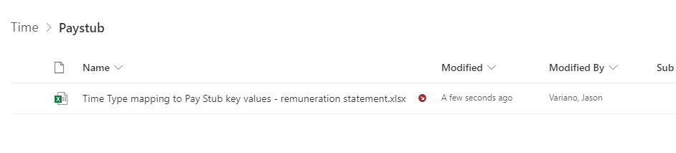

## Quota Report (ZHRQUOTA)

Users need to be able to view an employee’s quota balances by assignment for a particular date range and quota type. This report should output the following data:

* Begin Balance and End Balance for a period
* Usage in between period
* Accrual Amounts
* Compensated Amount
* Donated Amount
* Payout Information
* Paid Vs Earned (Illness)

# Appendix A: Vacation Accrual Rates (These Factors are housed at Payroll Parameter Table T511K-ZQFC*)

|  |  |  |  |  |  |  |  |  |  |  |  |  |  |  |  |  |
| --- | --- | --- | --- | --- | --- | --- | --- | --- | --- | --- | --- | --- | --- | --- | --- | --- |
| **VAC CODE** | **A** | **I** | **I** | **C** | **C** | **F** | **B** | **B** | **D** | **E** | **G** | **H** | **J** | **K** | **N** | **M** |
| **Accrual Rate** | **0.09232** | **0.08462** | **0.08462** | **0.07663** | **0.07693** | **0.06923** | **0.07693** | **0.07693** | **0.07308** | **0.06923** | **0.06539** | **0.06155** | **0.05770** | **0.03846** | **0.04087** | **0.04379** |
| **District Years of Service** | Executive Classes | **19 and up** | **19 and up** | **19 and up** | **19 and up** | **0 -18** | **19 and up** | **19 thru 23** | **18** | **17** | **16** | **15** | **4-14** | **0-3** < 35 hrs/wk  > 40 hrs/wk | **0-3** 37.50 - 39.50 hrs/wk | **0-3** 35 - 37 hrs/wk |
| 1AOX |  |  |  |  |  |  | **x** |  | **x** | **x** | **x** | **x** | **x** | **x** | **x** | **x** |
| 1APW |  |  |  |  |  |  | **x** |  | **x** | **x** | **x** | **x** | **x** | **x** | **x** | **x** |
| 1APX |  |  |  |  |  |  | **x** |  | **x** | **x** | **x** | **x** | **x** | **x** | **x** | **x** |
| 1ASX |  |  |  |  |  |  | **x** |  | **x** | **x** | **x** | **x** | **x** | **x** | **x** | **x** |
| 1BXX |  |  |  |  |  |  | **x** |  | **x** | **x** | **x** | **x** | **x** | **x** | **x** | **x** |
| 1CXX |  |  |  |  |  |  | **x** |  | **x** | **x** | **x** | **x** | **x** | **x** | **x** | **x** |
| 1DPX |  |  |  |  |  |  | **x** |  | **x** | **x** | **x** | **x** | **x** | **x** | **x** | **x** |
| 1DTX |  |  |  |  |  |  | **x** |  | **x** | **x** | **x** | **x** | **x** | **x** | **x** | **x** |
| 1DXX |  |  |  |  |  |  | **x** |  | **x** | **x** | **x** | **x** | **x** | **x** | **x** | **x** |
| 1EXX |  |  |  |  |  |  | **x** |  | **x** | **x** | **x** | **x** | **x** | **x** | **x** | **x** |
| 1LAX | **x** |  |  |  |  |  |  |  |  |  |  |  |  |  |  |  |
| 1LJX | **x** |  |  |  |  |  |  |  |  |  |  |  |  |  |  |  |
| 1LMX | **x** |  |  |  |  |  |  |  |  |  |  |  |  |  |  |  |
| 1LVX | **x** |  |  |  |  |  |  |  |  |  |  |  |  |  |  |  |
| 1NAX |  |  |  |  |  |  |  |  |  |  |  |  |  |  |  |  |
| 1NXX |  |  |  |  |  |  |  |  |  |  |  |  |  |  |  |  |
| 1SAS |  |  |  |  |  |  | **x** |  | **x** | **x** | **x** | **x** | **x** | **x** | **x** | **x** |
| 1SAX |  |  |  |  |  |  | **x** |  | **x** | **x** | **x** | **x** | **x** | **x** | **x** | **x** |
| 1SLL | **x** |  |  |  |  |  |  |  |  |  |  |  |  |  |  |  |
| 1SLX |  |  |  |  |  |  | **x** |  | **x** | **x** | **x** | **x** | **x** | **x** | **x** | **x** |
| 1SXX |  |  |  |  |  |  | **x** |  | **x** | **x** | **x** | **x** | **x** | **x** | **x** | **x** |
| 1VAC | **x** |  |  |  |  |  |  |  |  |  |  |  |  |  |  |  |
| 1VAD | **x** |  |  |  |  |  |  |  |  |  |  |  |  |  |  |  |
| 1VEX | **x** |  |  |  |  |  |  |  |  |  |  |  |  |  |  |  |
| **VAC CODE** | **A** | **I[29]** | **I[30]** | **C[31]** | **C[32]** | **F** | **B** | **B[33]** | **D** | **E** | **G** | **H** | **J** | **K** | **N** | **M** |
| **Accrual Rate** | **0.09232** | **0.08462** | **0.08462** | **0.07663** | **0.07693** | **0.06923** | **0.07693** | **0.07693** | **0.07308** | **0.06923** | **0.06539** | **0.06155** | **0.05770** | **0.03846** | **0.04087** | **0.04379** |
| **District Years of Service** | Executive  Classes | **19 and up** | **24 and**  **up** | **19 and up** | **19 and up** | **0 -18** | **19 and up** | **19 thru 23** | **18** | **17** | **16** | **15** | **4-14** | **0-3** < 35 hrs/wk  > 40 hrs/wk | **0-3**  37.50-39.50 hrs/wk | **0-3** 35 - 37 hrs/wk |
| 1VJX | **x** |  |  |  |  |  |  |  |  |  |  |  |  |  |  |  |
| 1VSX | **x** |  |  |  |  |  |  |  |  |  |  |  |  |  |  |  |
| 1VVX | **x** |  |  |  |  |  |  |  |  |  |  |  |  |  |  |  |
| 1YLX | **x** |  |  |  |  |  |  |  |  |  |  |  |  |  |  |  |
| 1ZDX |  |  |  |  |  |  | **x** |  | **x** | **x** | **x** | **x** | **x** | **x** | **x** | **x** |
| 1ZLX | **x** |  |  |  |  |  |  |  |  |  |  |  |  |  |  |  |
| 1ZSX |  |  |  |  |  |  | **x** |  | **x** | **x** | **x** | **x** | **x** | **x** | **x** | **x** |
| 1ZXX |  |  |  |  |  |  | **x** |  | **x** | **x** | **x** | **x** | **x** | **x** | **x** | **x** |
| 2MCX | **x** |  |  |  |  |  |  |  |  |  |  |  |  |  |  |  |
| 2MEX |  | **x** | **x** |  | **x** | **x** |  | **x** |  |  |  |  |  |  |  |  |
| 2MSX |  | **x** | **x** |  | **x** | **x** |  | **x** |  |  |  |  |  |  |  |  |
| 2MZX |  | **x** | **x** |  | **x** | **x** |  | **x** |  |  |  |  |  |  |  |  |
| 2PXX |  |  |  | **x** | **x** | **x** |  |  |  |  |  |  |  |  |  |  |
| 2USX |  |  |  | **x** | **x** | **x** |  |  |  |  |  |  |  |  |  |  |
| 2UTA |  |  |  | **x** | **x** | **x** |  |  |  |  |  |  |  |  |  |  |
| 2UTE |  |  |  | **x** | **x** | **x** |  |  |  |  |  |  |  |  |  |  |
| 2UTH |  |  |  | **x** | **x** | **x** |  |  |  |  |  |  |  |  |  |  |
| 2UTK |  |  |  | **x** | **x** | **x** |  |  |  |  |  |  |  |  |  |  |

# Appendix B: Illness Projection Values by Personnel Subarea

|  |  |  |  |  |  |  |
| --- | --- | --- | --- | --- | --- | --- |
| **Personnel Subarea** | **Personnel Subarea Description** | **No of Days** | **6/DAY** | **0.05 (Accrual Factor)** | **8/DAY** | **0.05 (Accrual Factor)** |
| **AAXX** | A-Basis/ Adult | 260 | 1560 | **78.00** | 2080 | **104.00** |
| **AFXX** | A-Basis/ Four-Track | 260 | 1560 | **78.00** | 2080 | **104.00** |
| **AGXX** | A-Basis/ General Calendar | 260 | 1560 | **78.00** | 2080 | **104.00** |
| **AJXX** | A-Basis/ Job Cost Calendar | 260 | 1560 | **78.00** | 2080 | **104.00** |
| **ATXX** | A-Basis/ Three-Track | 260 | 1560 | **78.00** | 2080 | **104.00** |
| **BAXX** | B-Basis/ Adult | 221 | 1326 | **66.30** | 1768 | **88.40** |
| **BFXX** | B-Basis/ Four-Track | 221 | 1326 | **66.30** | 1768 | **88.40** |
| **BGXX** | B-Basis/ General Calendar | 221 | 1326 | **66.30** | 1768 | **88.40** |
| **BJXX** | B-Basis/ Job Cost Calendar | 221 | 1326 | **66.30** | 1768 | **88.40** |
| **BSXX** | B-Basis/ Single-Track | 221 | 1326 | **66.30** | 1768 | **88.40** |
| **BTXX** | B-Basis/ Three-Track | 221 | 1326 | **66.30** | 1768 | **88.40** |
| **CAXX** | C-Basis/ Adult | 204 | 1224 | **61.20** | 1632 | **81.60** |
| **CFXX** | C-Basis/ Four-Track | 204 | 1224 | **61.20** | 1632 | **81.60** |
| **CGXX** | General Calendar/ C-Basis | 204 | 1224 | **61.20** | 1632 | **81.60** |
| **CJXX** | C-Basis/ Job Cost Calendar | 204 | 1224 | **61.20** | 1632 | **81.60** |
| **CSXX** | C-Basis/ Single-Track | 204 | 1224 | **61.20** | 1632 | **81.60** |
| **CTXX** | C-Basis/ Three-Track [34] | 204 | 1224 | **67.32/61.20** | 1632 | **89.76/81.60** |
| **CTXX (2UTK)** | C-Basis/ Three-Track [35] | 204 | 1224 | **67.32/60** | 1632 | **89.76/80** |
| **DSXX** | D-Basis/Single Track | 226 | 1356 | **67.80** | 1808 | **90.40** |
| **EAXX** | E-Basis/ Adult | 234 | 1404 | **70.20** | 1872 | **93.60** |
| **EFXX** | E-Basis/ Four-Track | 234 | 1404 | **70.20** | 1872 | **93.60** |
| **EGXX** | E-Basis/ General Calendar | 234 | 1404 | **70.20** | 1872 | **93.60** |
| **EJXX** | E-Basis/ Job Cost Calendar | 234 | 1404 | **70.20** | 1872 | **93.60** |
| **ESXX** | E-Basis/ Single-Track | 234 | 1404 | **70.20** | 1872 | **93.60** |
| **ETXX** | E-Basis/ Three-Track | 234 | 1404 | **70.20** | 1872 | **93.60** |
| **FFXX** | F-Basis/Four-Track | 247 | 1506 | **75.30** | 2008 | **100.40** |
| **KFXX** | K-Basis/ Four-Track | 214 | 1284 | **64.20** | 1712 | **85.60** |
| **Personnel Subarea** | **Personnel Subarea Description** | **No of Days** | **6/DAY** | **0.05 (Accrual Factor)** | **8/DAY** | **0.05 (Accrual Factor)** |
| **KGXX** | K-Basis/ General Calendar | 214 | 1284 | **64.20** | 1712 | **85.60** |
| **KSXX** | K-Basis/ Single-Track | 214 | 1284 | **64.20** | 1712 | **85.60** |
| **KTXX** | K-Basis/ Three-Track | 214 | 1284 | **64.20** | 1712 | **85.60** |
| **NTXX** | N-Basis/Three-Track | 252 | 1536 | **76.80** | 2048 | **102.40** |

# Appendix C: SAP Configuration Notes

This section will attempt to describe how the requirements from this document are implemented within SAP. ***It is a very high level description****.* It is intended to be a reference for users to know where to find data. For a lower level description of the configuration, please view the documentation attached to each schema and rule in SAP. The main schema for LLSD time evaluation is *ZM0C*.

## Quota Types (IT2006)

|  |  |  |
| --- | --- | --- |
| **Quota Type** | **Quota Text** | **Process Description** |
| **01** | Full-Pay Illness | Generates one per perner.  Effective over entire career.  Deducts from Illness absences. (schema reduces for PN/KC) |
| **02** | Half-Pay Illness | Generates one per perner each fiscal year.  Deducts from Illness absences. |
| **03** | Projected Illness Hours | Generates one per perner each fiscal year.  This is the full-pay illness generated for the fiscal to be used for "true illness" calculation.  Does not deduct with absences. |
| **04** | Earned Illness Hours | Generates one per perner each fiscal year.  This is the full-pay illness earned for the fiscal to be used for "true illness" calculation.  Accrues each month for eligible hours reported.  Does not deduct with absences. |
| **05** | Personal Necessity | Generates one per perner each fiscal year.  Deducts from PN absences. |
| **06** | Kin Care | Generates one per perner each calendar year.  Deducts from KC absences. |
| **08** | Vacation Hours | Generates one per perner.  Effective over entire career.  Deducts from Vacation absences. |
| **09** | DS Vacation Hours | Generates one per perner.  Effective over entire career.  Deducts from Vacation absences.  *Only exists for employees in ESG D1* |
| **10** | Vested Vacation Hours | Quota type only exists for specific employees identified though manual load.  Used for annual vacation adjusted for vested vacation and for lump sum vacation process.  Does not deduct with absences. |
| **11** | Compensatory Balance | Generates one per perner each year from September (for eligible employees only).  Deducts from CU absences |
| **12** | PNWD Balance | Generates one per perner each fiscal year (for eligible employees only).  Deducts from all absences. |
| **15** | Parental Leave | PL entitlement in hours (PL remaining entitlement X assignment hours) |
| **98** | Excess Vacation Hours | This quota is only updated during the Lump Sum Vacation payout process.  For employees who receive a LSV payout with excess vacation, the excess is stored in the quota type.  Does not deduct with absences. |

## Time Transfer Types (IT2012)

|  |  |  |
| --- | --- | --- |
| **Time Type** | **Time Type Text** | **Process Description** |
| **VCAP** | 18 Months VA Cap | For employees with vacation balances but were never vacation eligible in SAP, update this time type with the employees 18-month vacation cap. A time evaluation message will indicate such employees that states "Employee has not vacation cap" |
| **VOUT** | Vac. Payout non-ZSEP Trigger | This time type triggers a vacation payout for vacation ineligible employees. The hour’s value should be 1. See work instructions for *ZHRVACPAYOUT* for the proper way to for the proper process for managing this time type. |
| **VWAV** | Excess Vacation Waiver | Use this time type on 6/30 to indicate the number of vacation hours over the employee's CAP that should be waived from Excess Vacation. |
| **ZCMP** | Comp payout flag | This time type is generated by a dynamic action for Comp Time eligible employees when they change to a grouping that is not Comp Time eligible (or separate). It will pay out any existing comp time balance. The hour’s value should be 1. |
| **ZPNW** | PNWD payout flag | This time type is generated by a dynamic action for PNWD eligible employees when they change to a grouping that is not PNWD eligible (or separate). It will pay out any existing PNWD balance. The hour’s value should be 1. |
| **ZQTO** | Quota Check Override flag | If this flag exists, the logic to generate the UP wage type exhausted quotas is bypassed. The employee will be paid for quota they do not have, but the quota balance will become negative. |
| **ZSEP** | Vacation Payout Flag | This time type is generated by a dynamic action for all employees when they separate from LLSD. It will payout all quotas and calculates unearned illness. The hour’s value should be 1. |
| **ACAE** | Assgn Comp/Deceased Flag | This time type is generated by a dynamic action on assignments that separate for the reason "Completion of Assignment". It will reset all quotas on the assignment (but not pay out). The hour’s value should be 1. |
| **Z709** | Quota Changes Retro From7/1/09 | This time type can be used to set the effective date for quota project changes from 7/1/2010 to 7/1/2009. Create it on all assignments with a begin date of 7/1/2009 (or first active date) and an end date of 6/30/2010 (or last active date). The hour’s value should be 1.  For employees with concurrent assignments, this flag must exist on all assignments. |
| **QI10** | 10/90 Indicator | This time type is used to indicate an employee has used their 10/90 benefit prior to SAP go-live. The hour’s value should be 1. |
| **ZQ03** | Quota Accrual: Main Assgn | This time type is set for a non-main assignment when the main assignment is not active. As of 7/1/2010, this time type is no longer needed. The hour’s value should be 1. |
| **ZQI1** | Cat Illness Indicator | This time type indicates an employee is on a Catastrophic Illness leave. The begin date should be the start of the leave, and the end date is the return date. 12/31/9999 indicates the employee has no returned. The hour’s value should be 1. See work instructions for *ZHR_DONATION* for the proper process for managing this time type. |
| **ZQI2** | Cat Illness Donation | This time type indicates the number of hours donated to an employee on a Catastrophic illness leave. See work instructions for *ZHR_DONATION* for the proper process for managing this time type. |
| **INHR** | CL/AALA AIP hours | This is the amount the illness balance on June 30th should be reduced by for calculating the employee's true illness balance for AIP (from fiscal year 1994-1995). |
| **Z109** | 10/90 IL projection flag | This flag is being used to feed the time evaluation to trigger 10/90 illness projection on the first day of Fiscal Year (July 1st) |

## Reporting Time Types (ZES/SALDO)

In addition to the time types in the above time transfer type processing, the following are some of the important time types that can be useful for reporting quota processing. Use PT_BAL00, PT66, or other reports that access time evaluation results to view.

|  |  |  |
| --- | --- | --- |
| **Time Type** | **Time Type Text** | **Process Description** |
| **INGO** | CL/AALA AIP Goal | This is the AIP true illness balance goal to receive the classified incentive. |
| **INDA** | CL/AALA AIP Days | This is the true illness balance in days which is compared to INGO to determine AIP eligibility. |
| **VZAP** | Excess Vacation Zapped | The number of excess vacation hours zapped in the fiscal year (on June 30th) |
| **QVAC** | VC - Accrual Rate | The employee's vacation accrual rate. |
| **VACP** | 18-month Vacation Cap | The employee's 18-month vacation maximum. |
| **TCAP** | Total Cap-18Mnths+Vested | The employee's total vacation maximum (18-month vacation maximum + vested hours.) |
| **DYRS** | District Years of Service | District years of service used to determine vacation accrual rate. |
| **ZIHR** | Total IL Hrs/ year/Person | Total illness hours (FP + HP) the employee was given in the fiscal year  **R2285** – RH004_000 – Time Data Maintainers of PSB have given access to this time type in order to change HPI balance via IT2013. |
| **P130** | 130-Day Probationary | The probationary counter to determine if the employee has passed the 130 day probationary period. |
| **ZQI3** | Cat Ill HPI Adjustment | Illness hours reported that still receive earned illness, accrue vacation, count towards step advance, etc can be tracked in time type ZQI3. |

## Wage Types

Below is some of the important wage types used in the absence quota management process.

|  |  |  |
| --- | --- | --- |
| **Wage Type** | **Wage Type Text** | **Process Description** |
| **0140** | Compensatory Time Lump Sum | Wage Type used to pay out Comp Time |
| **0443** | Unearned Illness (H) | This wage type is used to collect the unearned illness amount when an employee separates. It collects at the half pay rate. |
| **0445** | Unearned Illness (F) | This wage type is used to collect the unearned illness amount when an employee separates. It collects at the full pay rate. |
| **0477** | Lump sum Vac. Bank Hrs Pay | Wage Type used to pay out Vested Vacation Time |
| **0478** | Lump sum Vac. Bank Rate | This wage type is loaded in IT0015 for employees with vested vacation. It holds the rate to pay out the vested vacation hours. |
| **0483** | Lump Sum Vac Carry Fwd | This wage type is loaded in IT0015 for employees with vacation balances that were never eligible for vacation in SAP (from 1/1/2010 forward). It holds the rate to pay the vacation out at (for the *ZHRVACPAYOUT* process) |
| **0484** | Vacation lump Sum Pay | Wage Type used to pay out Vacation Time |
| **0485** | Unpaid Time (UP) | When an absence is retroactively exhausted after an absence has already been input, this wage type is generated. It does not pay. |
| **0915** | Pay Non-Working Days | Wage Type used to pay out PNWD hours and PNWD AIP. |

# Appendix D: Addendum to Bargaining Contract Agreements

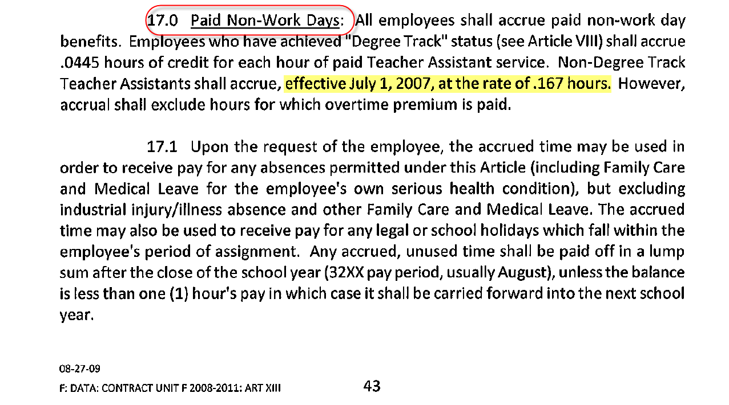

**SIDE NOTE:**

*The new accrual factor of 0.0167 which is effective July 1, 2007 was modified in SAP via R2679.*

*However, the request to implement this change was only made aware to ITD-BASE by Payroll Services Branch on the 3rd quarter of Fiscal Year 2011-2012. With Payroll Services’ decision to avoid more system problems, the new accrual rate will be applied effective July 1, 2012 going forward. Retroactive accruals (for periods 07/01/2007 thru 06/30/2012) will be addressed on a case by case basis.*

# Appendix E: HR Action Codes and Action Type:

|  |  |
| --- | --- |
| Action | Name of the Action Type |
| CS | Change in Enterprise Structure |
| CW | Change in Work Schedule |
| HN | New Hire |
| HR | Rehire |
| MT | Additional Assignment (illness-eligible) |
| NN | 10/90 Illness Accrual |
| OR | Reassignment |
| RL | Return from Leave |

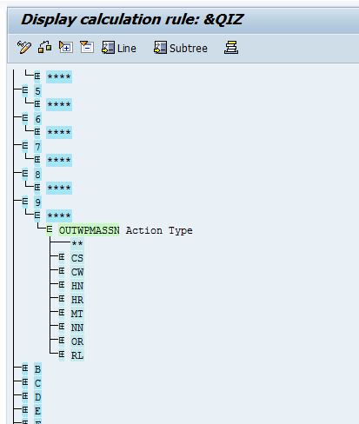

# Appendix F: Vacation Accrual Factors

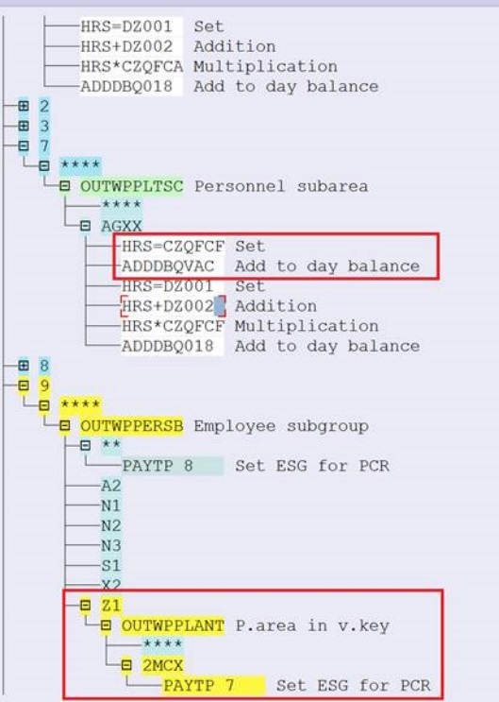 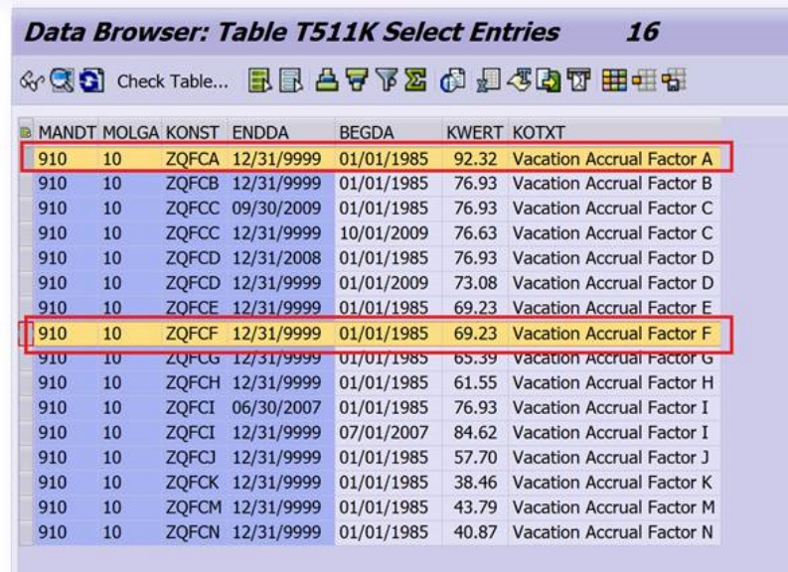

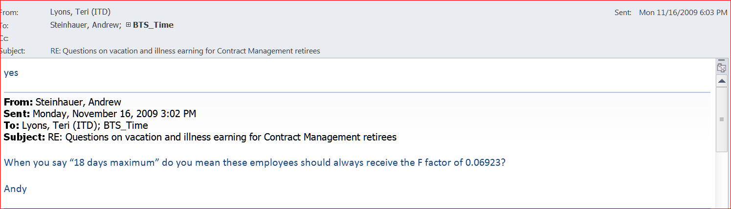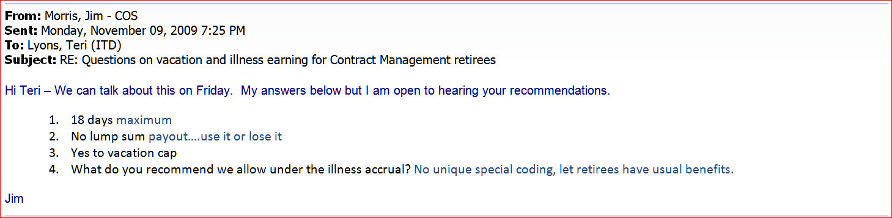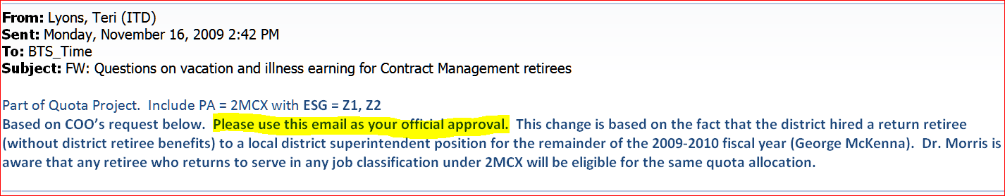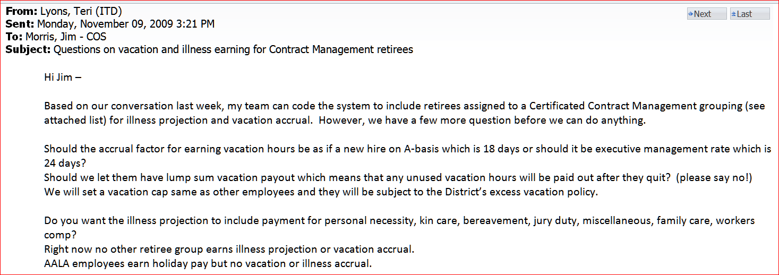

# Appendix G: ZSEP and payout:

Original code paid out and did quota reset if Main assignment had ZSEP.

ZSEP is created for any separation action with any reason code except Completion of Assignment.

But there were issues:

1. Additional assignments were separated but using other reason code which resulted in ZSEP. This in turn created schema bugs as Payout did not happen if ZSEP not on main, but the ZSEP on additional was creating Quota reset and not Payout.
2. There were sometimes 2 Vacation earning or 2 Illness earning assignments and main separated but the other assignment continued active. This was creating Payout and Quota reset but that should not happen.

So new solution with this request - R7900 – Half pay issue (title does not have ZSEP but includes ZSEP changes).

**New Solution:**

If any Vacation earning or Illness Eligible assignment is active next day then even if ZSEP is there on any assignments including MAIN, the Payout will NOT happen and no quota reset will happen.

If there is a ZSEP on Main assignment but if there happens to be other assignments active that are NOT Vacation earning nor Illness eligible then Payout will happen.

Sometimes we have seen separated Main assignment where they leave a Z Summer assignment open. But in this case payout will happen.

Below matrix illustrates new solution when Payouts and quota resets will happen:

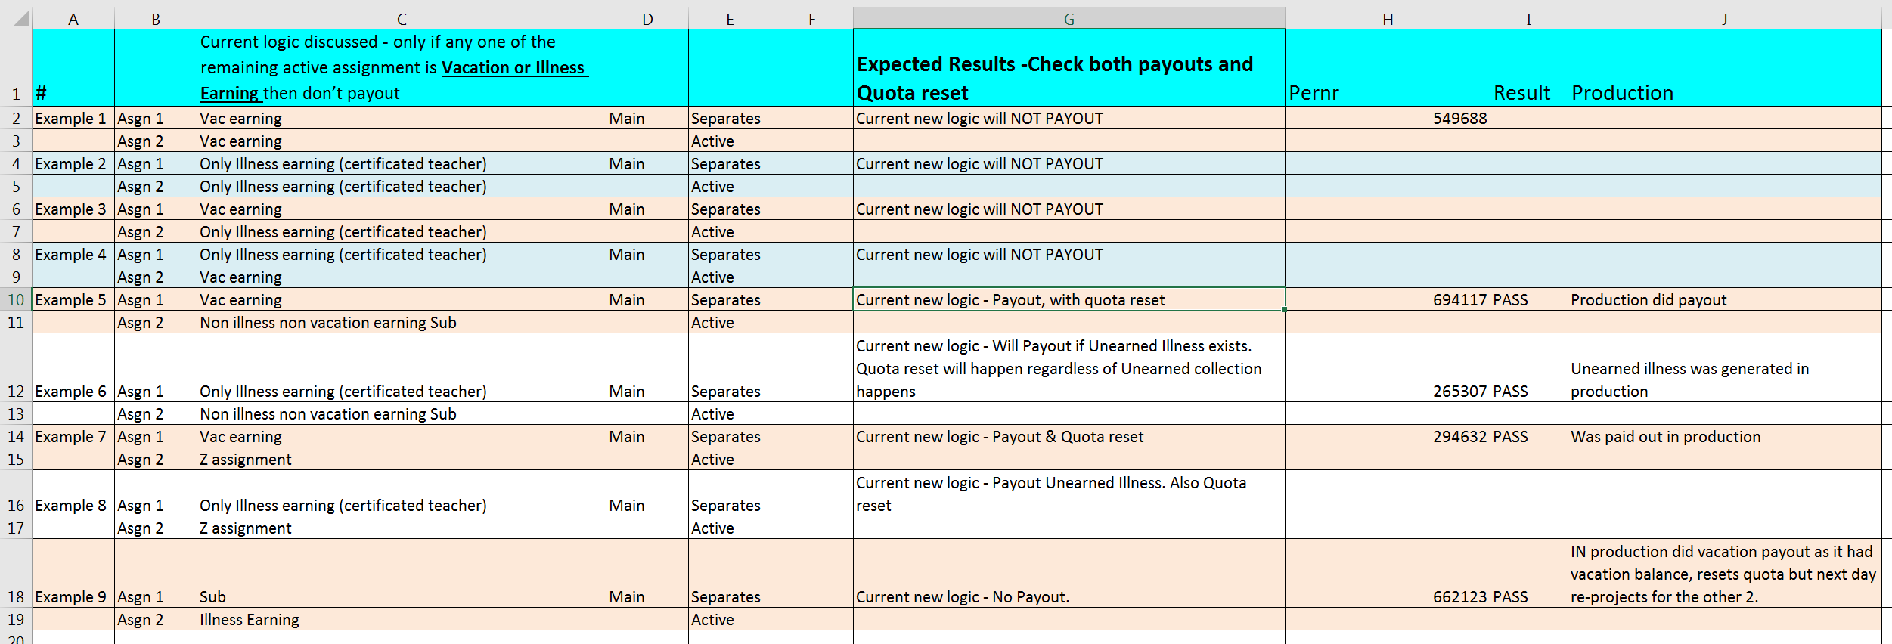

1. This process is effective in SAP 7/1/2010 (with an option to override to 7/1/2009 on the personnel number level)
2. See probationary period within Illness section for a description of a permanent employee.
3. Vacation payout for vacation ineligible employees is effective in SAP 1/1/2010.
4. Prior to 1/1/2010, INGO (and thus AIP) may have been miscalculated if the employee had multiple assignments or was newly hired. Furthermore, prior to 1/1/2010, AIP was calculated based on the full-pay balance and not the true illness balance.
5. Projections which use the FTE factor of less than 100% are effective in SAP 7/1/2010 (with an option to override to 7/1/2009 on the personnel number level
6. This process is effective in SAP 7/1/2010 (with an option to override to 7/1/2009 on the personnel number level)
7. Projections which use the FTE factor of less than 100% are effective in SAP 7/1/2010 (with an option to override to 7/1/2009 on the personnel number level)
8. This process is effective in SAP 7/1/2010 (with an option to override to 7/1/2009 on the personnel number level)
9. This process is effect in SAP 7/1/2008
10. This process is effective in SAP 7/1/2010 (with an option to override to 7/1/2009 on the personnel number level)
11. This process is effective in SAP 7/1/2010 (with an option to override to 7/1/2009 on the personnel number level)
12. This process is effective in SAP 7/1/2010 (with an option to override to 7/1/2009 on the personnel number level)
13. This process is effective in SAP 7/1/2010 (with an option to override to 7/1/2009 on the personnel number level)
14. Unearned Illness recovery for projection adjustments is effective in SAP 7/1/2010 (with an option to override to 7/1/2009 on the personnel number level)
15. This process is effective in SAP 7/1/2010 (with an option to override to 7/1/2009 on the personnel number level)
16. This process is effective in SAP 7/1/2010 (with an option to override to 7/1/2009 on the personnel number level)
17. This process is effective in SAP 7/1/2010 (with an option to override to 7/1/2009 on the personnel number level)
18. PN projections for 1SAS only begin in SAP 7/1/2009
19. PN projection changed 7/1/2010 to include assignment hours of concurrent assignments (with an option to override to 7/1/2009 on the personnel number level).
20. PN flip-flops effective in SAP 7/1/2010 (with an option to override to 7/1/2009 on the personnel number level)
21. KC projection changed 7/1/2010 to include assignment hours of concurrent assignments (with an option to override to 7/1/2009 on the personnel number level)
22. KC flip-flops effective in SAP 7/1/2010 (with an option to override to 7/1/2009 on the personnel number level)
23. Non-Degree employees accrue at this rate for any hours paid prior to 07/01/2012.
24. With Payroll Services’ decision to avoid more system problems, the new accrual factor will be applied effective 07/01/2012 going forward. Retroactive accruals (for periods 07/01/2007 thru 06/30/2012) will be addressed on a case by case basis.
25. Non-Degree employees accrue at this rate for any hours paid on 07/01/2012 and after. Please see Appendix D on an excerpt from the Unit F 2008-2011 contract agreement under Article XIII – Leaves of Absence.
26. This process is effective in SAP 10/1/2009
27. This process is effective in SAP 10/1/2009
28. This process is effective in SAP 10/1/2009
29. 2M* effective from 7/1/2007 to 6/30/14 only
30. 2M* effective after 7/1/14
31. 2U* & 2P* effective after 10/1/2009
32. 2M* effective before 7/1/2007. 2U* & 2P* effective before 10/1/2009
33. 2M* effective after 7/1/14
34. Effective 7/1/2010, projection for CTXX reduced to 61.2 hours (81.60 hours for 8 hour/day employees) for non-2UTK employees
35. Effective 7/1/2010, projection for 2UTK/CTXX reduced to 66 hours for a 6.6 hour assignment (80 hours for 8 hour/day employees)